ModelMuse Beta 2

With the release of ModelMuse version 4.3, I am also releasing an updated beta version of ModelMuse that includes everything included in ModelMuse version 4.3 as well as partial support for PEST

# Flow Observations, MODFLOW 6

I have changed the way that flow observations for MODFLOW 6 are specified. This section describes how flow observations for MODFLOW 6 are specified.

Observations of flow through the boundaries defined in the CHD, DRN, RIV, or GHB packages are defined using objects. Each object can define a group of flow boundary cells that are part of any flow boundary observations defined by that object. If the object defines flow boundaries of the same type, the boundary observations defined by that object will encompass all the flow boundaries cells of that type defined by that object. For example, this illustrates how an object can define both drain boundaries and a drain boundary observation.

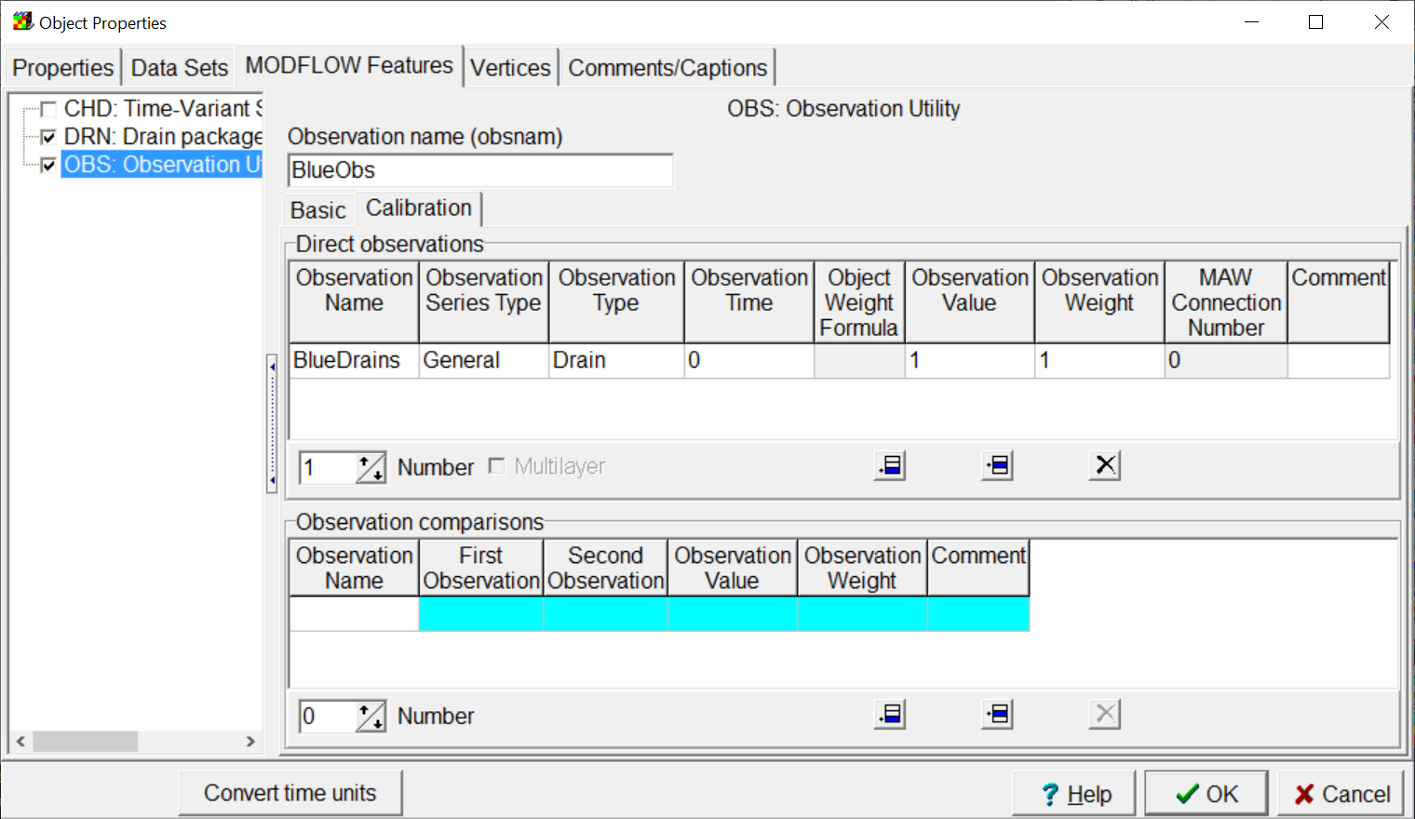

If the object does not define flow boundaries of the same type, the boundary observations will encompass all the flow boundary cells of that type that are in cells selected by the object that are not already part of another flow observation of that type. Because of this rule, no flow boundary cell can be part of more than one group of flow observation. For example, this object defines drain observations but does not define any drain boundaries. The drain cells that are part of this observation will be defined by other objects.

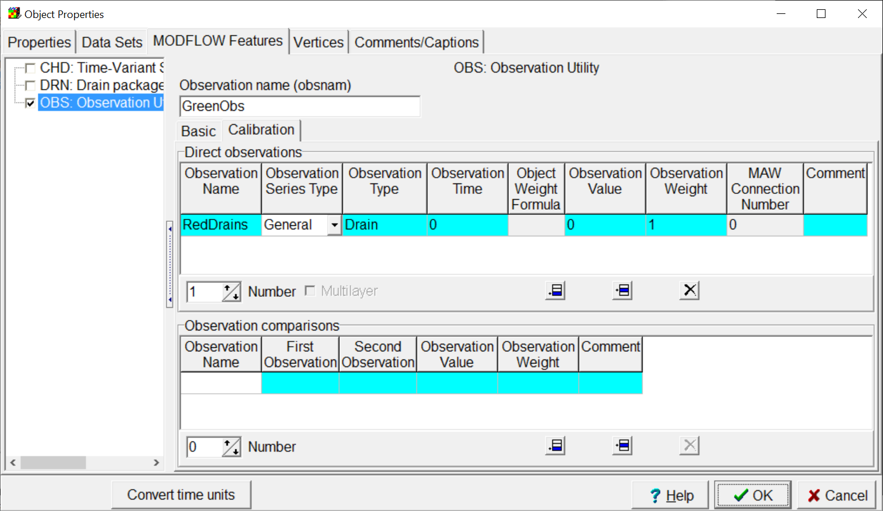

In the illustration below, there are three objects. The red line defines drains but does not define any drain observations. The blue line defines both drains and a drain observation. The drain observation would include the four drain cells in row ten intersected by the blue line. The green polygon defines a drain observation but does not define any drains. The drain observation would include the two drain cells intersected by the red line in rows 9 and 10 that are inside the green polygon. It would not include any of the drain cell defined by the blue line even though one of them is inside the green polygon because that drain cell is already part of the drain observation defined by the blue line.

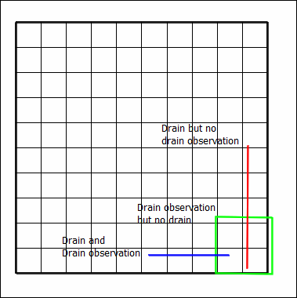

# Multilayer Head and Drawdown Observations, MODFLOW 6

Head observations are defined by point observations on the top view of the model that have two Z formulas defined in such a way that the point object intersects more than one layer. However, there is an additional requirement for such a point to define a multilayer observation; the multilayer checkbox on the calibration tab must be checked as illustrated below. If it is not checked, the observation will be treated as a single cell observation and the cell that has the longest length of intersection between the cell and the screen length (as defined by the Z formulas) will be the cell used for the observation.

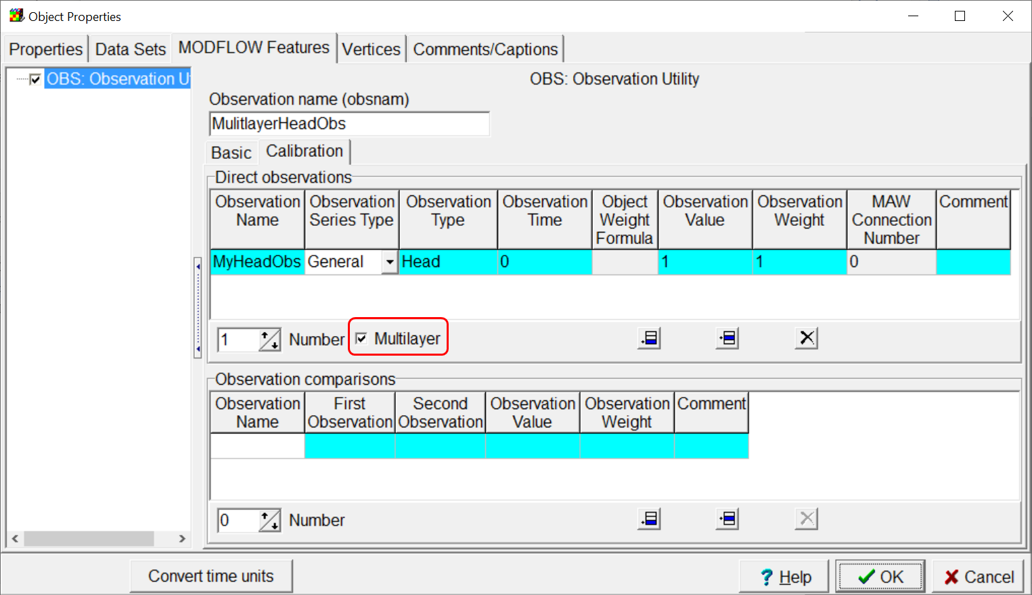

The weights applied to the individual cells that make up the multilayer head observations will be based on the product of the cell hydraulic conductivity in the X direction (Kx) and the length of intersection between the vertical well screen and the cell.

# Parameter Substitution, MODFLOW 6

This beta version will create template files for the following MODFLOW 6 packages, CHD, DRN, RIV, GHB, RCH, and EVT. The templates can be used with the enhanced template processor. In each of the template files, formulas are defined that involve the parameters for those packages. The formulas multiply the parameter values and a constant. To use with PEST, the PVAL file for the model must be modified by PEST. The enhanced template processor, can then use the modified PVAL file generated by PEST along with the template generated by ModelMuse to create the MODFLOW input file.